**Assignment 1: Data Analytics with Tableau**

* **Name: K AISHA RUQSHAN**

**• Roll Number: 22BFA32045**

**• Course: Data Analytics with Tableau**

**• Assignment: Assignment 1**

**Title:**

*Supermarket Sales Data Visualization and Analysis*

**Introduction:**

This assignment focuses on analyzing supermarket sales data collected from three

branches over a period of three months. Using Tableau, various visualizations were

created to understand sales trends, customer distribution, and product performance.

The insights from this analysis can help the supermarket improve decision-making,

marketing strategies, and customer experience.

**Visualizations:**

1. **Bar Chart: Total Sales by Product Line**

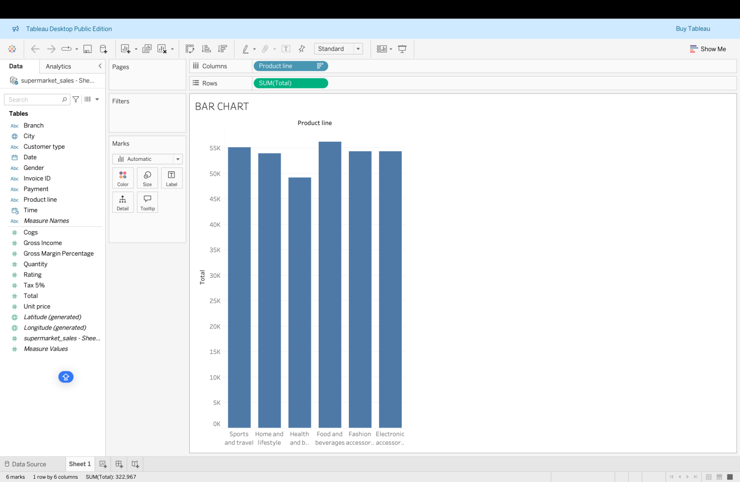

**Description:**This bar chart shows the total sales for each product line. It

helps identify which product lines are generating the most revenue.

1. **Pie Chart: Payment Method Distribution**:

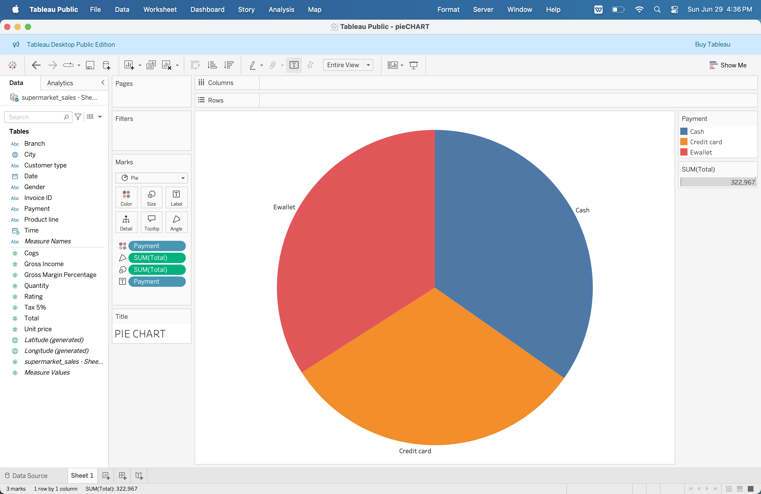

Description:

The pie chart displays the proportion of different payment methods used by

customers, such as Cash, Credit Card, and Ewallet.

1. **Stacked Bar Char**t: Total Sales by City and Gender:

**• Description**: This stacked bar chart illustrates total sales across different cities, separated

by customer gender. It provides a clear view of how gender contributes to

sales in each city

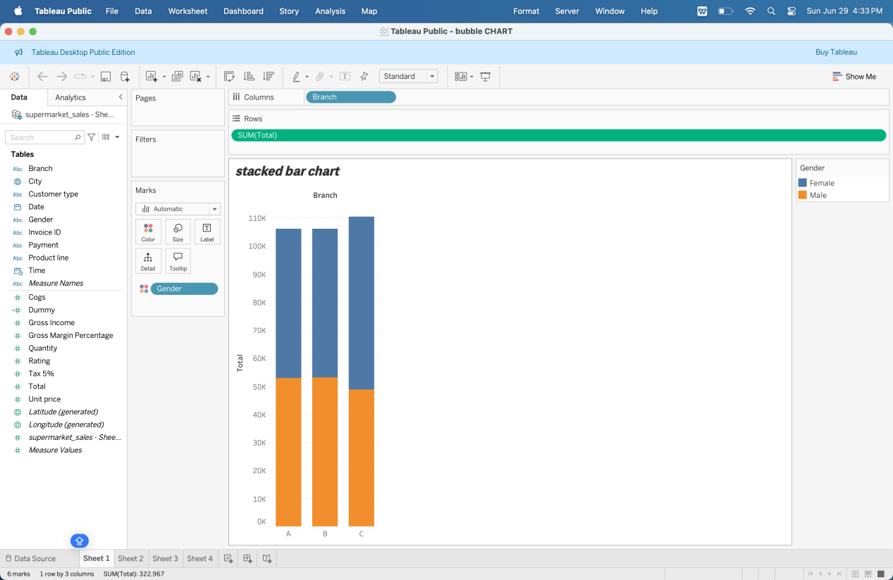

1. **Line Chart: Daily Sales Trend:**

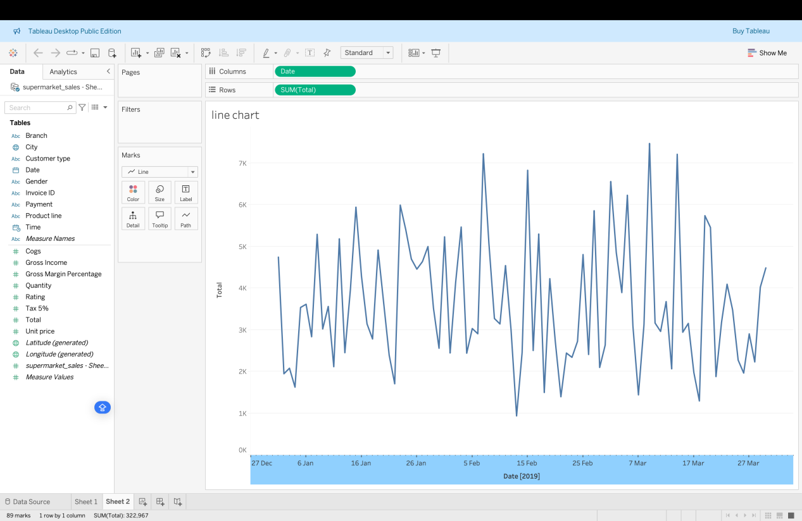

**Description:**

The line chart visualizes the daily sales trend over three months, helping to identify

sales patterns and peaks.

1. **Bubble Chart: Quantity vs Gross Income by Product Line:**

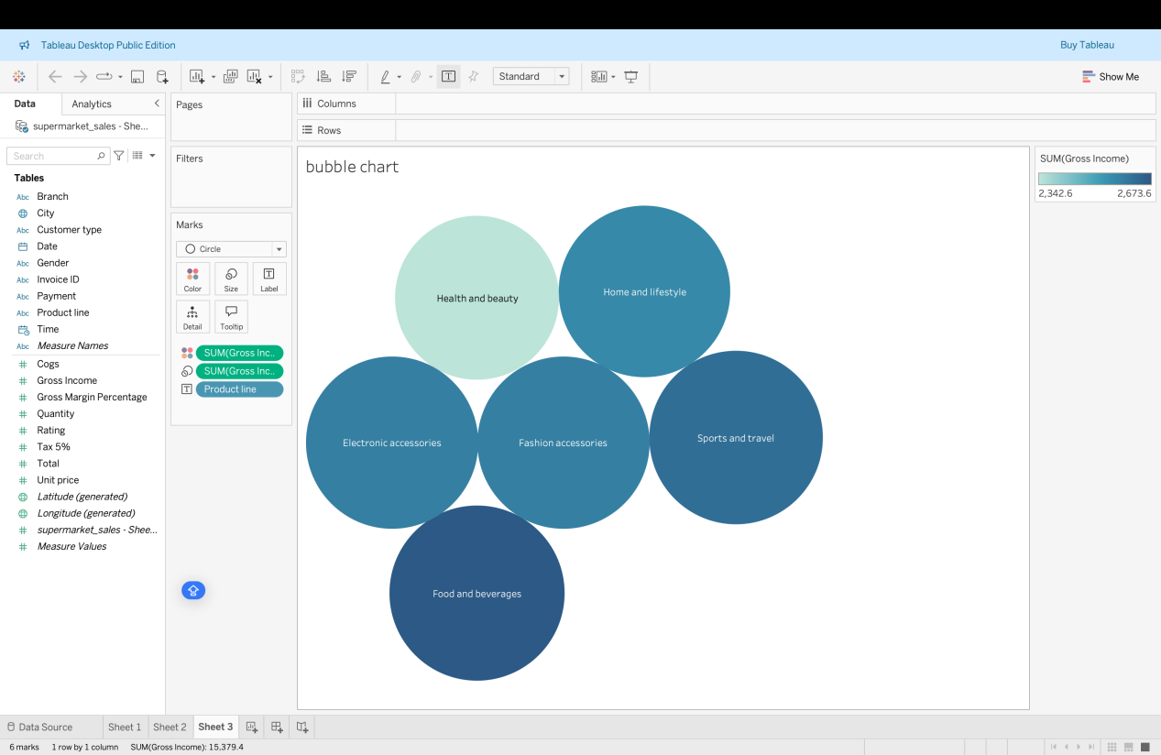

**Description:**

The bubble chart shows the relationship between quantity sold and gross income

for each product line. The size of the bubble represents the total sales volume.

**Conclusion:**

Through this analysis, we observed key patterns in customer preferences, product performance, and payment methods. These visualizations provide valuable insights that can support business growth and enhance customer satisfaction. Tableau's visual tools made it easy to identify trends and compare different factors effectively.